System Design
Michael Mays
Sept 29, 2019

Systems Design
Introduction
System design is the phase that bridges the gap between problem domain and the existing system in a manageable way. This phase focuses on the solution domain. It is the phase where the SRS document is converted into a format that can be implemented and decides how the system will operate (Diehl & Christiaans, 2015). In this phase, the complex activity of system development is divided into several smaller sub-activities, which coordinate with each other to achieve the main objective of system development.

Outputs for System Design
System design will give the following outputs −
A. Infrastructure and organizational changes for the proposed system.
The hierarchical structure will represent the authority over accounts; the end user of a parent account has authority over the end user of a sub-account. Every hierarchy will have an Account Administrator, who is able to view financial information, and modify certain account characteristics for all the accounts in the hierarchy.
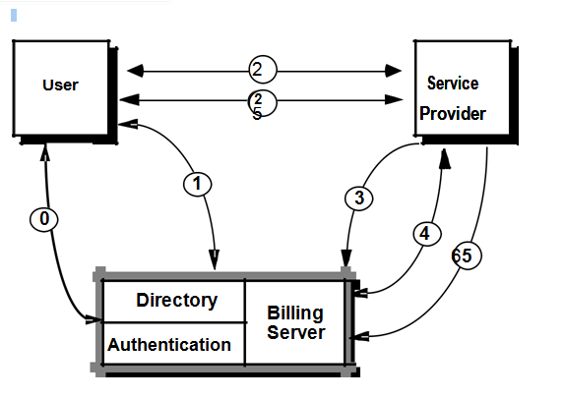
B. Billing and usage information will be aggregated by various branches of the hierarchical structure, or detailed information for each node in the structure can be supplied. The organization will now have the ability to give managers privileges to modify some of the information for the accounts of their subordinates. This new hierarchical structure will allow the account environment within the Internet Billing Server to mirror the environment within the organization.
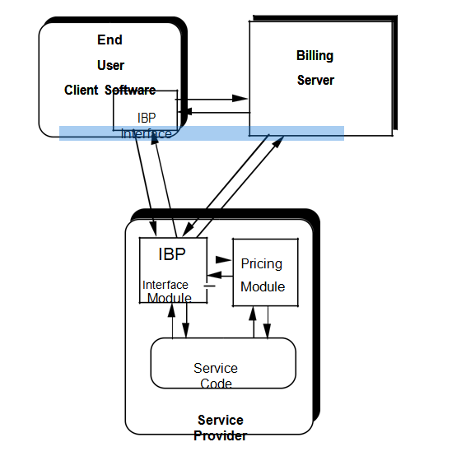
C. The new system will also have a data schema which will be a relational schema. It will also contain a metadata that will define the tables/files and columns/data-items. A function hierarchy diagram or web page map will graphically describe the program structure. Lastly, there will be an actual code for each module in the program.

Inputs to System Design
System design takes the following inputs −
A. Statement of work
The proposed system Burton’s Business and the IT System Analyst Company (BBISAC) will allow the finance department of Precision Electronic Parts (PEP) to have more and better control on the invoice development when receiving order, billing and collect payments, the proposal will aid to eliminate late billing and invoicing, and payment collection as also reduce much of processing errors.
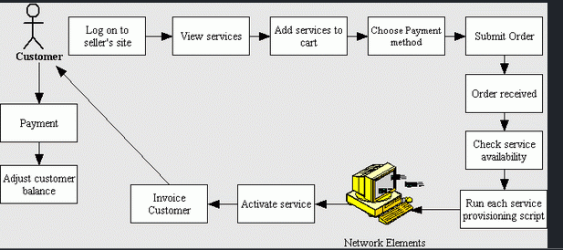
B. Proposed system requirements including a conceptual data model, modified DFDs, and Metadata (data about data).
Prior to engaging in a network-based transaction, an end user must first establish an account with the Internet Billing Server. In our design, any number of accounts may be organized in a hierarchical fashion by allowing each account to have sub-accounts, each of which is also an account. 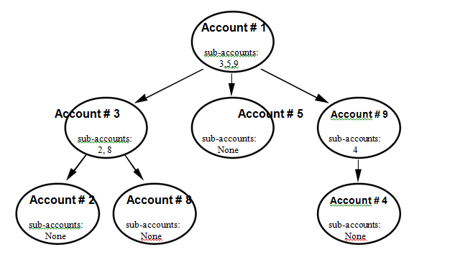

C. Physical Design
Physical design relates to the actual input and output processes of the new system. It focuses on how data is entered into the new system, verified, processed, and displayed as output. It produces the working system by defining the design specification that specifies exactly what the candidate system does. It is concerned with user interface design, process design, and data design.
It consists of the following steps −
- Specifying the input/output media, designing the database, and specifying backup procedures.
- Planning system implementation.
- Devising a test and implementation plan, and specifying any new hardware and software.
- Updating costs, benefits, conversion dates, and system constraints.

Architectural Design
It is also known as high level design that focuses on the design of system architecture. It describes the structure and behavior of the system. It defines the structure and relationship between various modules of system development process.

Conceptual Data Modeling
It is representation of organizational data which includes all the major entities and relationship. System analysts develop a conceptual data model for the current system that supports the scope and requirement for the proposed system.
The main aim of conceptual data modeling is to capture as much meaning of data as possible. Most organization today use conceptual data modeling using E-R model which uses special notation to represent as much meaning about data as possible.

Entity Relationship Model
It is a technique used in database design that helps describe the relationship between various entities of an organization.

Terms used in E-R model
- ENTITY − It specifies distinct real world items in an application. For example: vendor, item, student, course, teachers, etc.
- RELATIONSHIP − They are the meaningful dependencies between entities. For example, vendor supplies items, teacher teaches courses, then supplies and course are relationship.
- ATTRIBUTES − It specifies the properties of relationships.
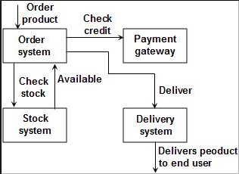

Database Design
It describes how records will be stored within a file.
The new system will use four file organization methods −
- Serial − Records will be stored in chronological order. This method will be vital for recording of telephone charges, ATM transactions, and Telephone queues.
- Sequential − Records will be stored in order based on a key field which contains a value that uniquely identifies a record. This will be used to store phone directories.
- Direct − each record will be stored based on a physical address or location on the device. Address is calculated from the value stored in the record’s key field. Randomizing routine or hashing algorithm does the conversion.
- Indexed − Records can be processed both sequentially and non-sequentially using indexes.

A. File Access
One will be able access a file using either Sequential Access or Random Access. File Access methods allow computer programs read or write records in a file. The following mehods will be available:

Sequential Access
Every record on the file is processed starting with the first record until End of File (EOF) is reached. It is efficient when a large number of the records on the file need to be accessed at any given time. Data stored on a tape (sequential access) can be accessed only sequentially.

Direct (Random) Access
Records are located by knowing their physical locations or addresses on the device rather than their positions relative to other records. Data stored on a CD device (direct-access) can be accessed either sequentially or randomly.

Types of files that will be used in the new system
Following are the types of files used in an organization system −
- Master file – It will contain the current information for a system. For example, customer files and telephone directory.
- Table file − It is a type of master file that changes infrequently and stored in a tabular format. It will be used for storing customer details such as Zip code.
- Transaction file – It will contain the day-to-day information generated from business activities. It is used to update or process the master file. For example, Addresses of the employees.
- Temporary file − It will be created and used whenever needed by a system.
- Mirror file − They are the exact duplicates of other files. Help minimize the risk of downtime in cases when the original becomes unusable. They must be modified each time the original file is changed.
- Log files − They contain copies of master and transaction records in order to chronicle any changes that are made to the master file. It facilitates auditing and provides mechanism for recovery in case of system failure.
- Archive files − Backup files that contain historical versions of other files.

B. Documentation Control
Documentation is a process of recording the information for any reference or operational purpose. It helps users, managers, and IT staff, who require it. It is important that prepared document must be updated on regular basis to trace the progress of the system easily (Awad & Khanna, 2015). After the implementation of system if the system is working improperly, then documentation will help the administrator to understand the flow of data in the system to correct the flaws and get the system working.

Advantages
- It will reduce system downtime, cut costs, and speed up maintenance tasks.
- It will provide a clear description of formal flow of present system and help to understand the type of input data and how the output can be produced.
- It will provide an effective and efficient way of communication between technical and nontechnical users about system.
- It will facilitate the training of new user so that he can easily understand the flow of system.
- It will help the user to solve the problems such as troubleshooting and help the manager to take better final decisions of the organization system.
- It will provide better control to the internal or external working of the system.

C. User Documentation
It will include the instructions and information to the users who will interact with the system. For example, user manuals, help guides, and tutorials. User documentation is valuable in training users and for reference purpose (Williams, 2016). It must be clear, understandable, and readily accessible to users at all levels.
User documentation will include −
- A system overview that clearly describes all major system features, capabilities, and limitations.
- Description of source document content, preparation, processing, and, samples.
- Overview of menu and data entry screen options, contents, and processing instructions.
- Examples of reports that are produced regularly or available at the user’s request, including samples.
- Security and audit trail information.
- Explanation of responsibility for specific input, output, or processing requirements.
- Procedures for requesting changes and reporting problems.
- Examples of exceptions and error situations.
- Frequently asked questions (FAQs).
- Explanation of how to get help and procedures for updating the user manual.

System Documentation
System documentation serves as the technical specifications for the IS and how the objectives of the IS are accomplished. Users, managers and IS owners need never reference system documentation. System documentation provides the basis for understanding the technical aspects of the IS when modifications are made.
- It describes each program within the IS and the entire IS itself.
- It describes the system’s functions; the way they are implemented, each program's purpose within the entire IS with respect to the order of execution, information passed to and from programs, and overall system flow.
- It includes data dictionary entries, data flow diagrams, object models, screen layouts, source documents, and the systems request that initiated the project.
- Most of the system documentation is prepared during the system analysis and system design phases.
- During systems implementation, an analyst must review system documentation to verify that it is complete, accurate, and up-to-date, and including any changes made during the implementation process.

References
Awad, M., & Khanna, R. (2015). Efficient learning machines: theories, concepts, and applications for engineers and system designers. Apress.
Diehl, J. C., & Christiaans, H. H. C. M. (2015). Product service system: The future for designers. In Proceedings of the International Design Conference of KSDS and ADADA with CUMULUS (pp. 17-18).
Williams, T. (2016). EMC for product designers. Newnes.

